‘S to express possession - Family Tree

We can also use **´s to talk about family relationships.**

Look at this family tree. Pay attention to the examples and complete the sentences:

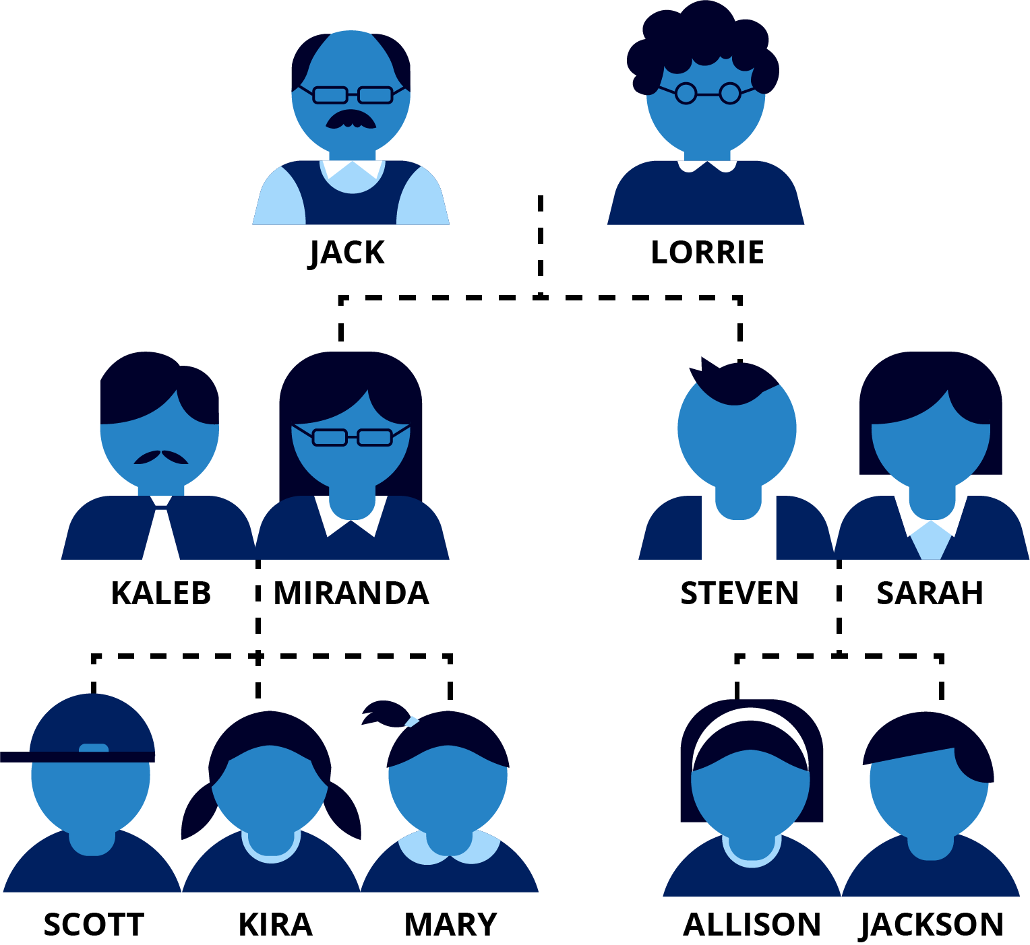

**Examples:**

* Jack is Miranda’s father
* Scott is Kira’s brother
* Sarah is Steven’s wife

Who is Lorrie to Steven?

Who is Jackson to Sarah?

Who is Kira to Allison?